**What is a Document Object Model ( DOM ) ?**

The Document Object Model (DOM) is a cross-platform and language-independent interface that treats an XML or HTML document as a tree structure wherein each node is an object representing a part of the document.

The DOM represents a document with a logical tree.

Each branch of the tree ends in a node.

DOM methods allow programmatic access to the tree with them one can change the structure, style or content of a document.

Nodes can have event handlers attached to them. Once an event is triggered, the event handlers get executed

When a web page is loaded, the browser creates a Document Object Model of the page, which is an **object oriented representation of an HTML document** that acts as an interface between JavaScript and the document itself.

For Example, the following HTML document 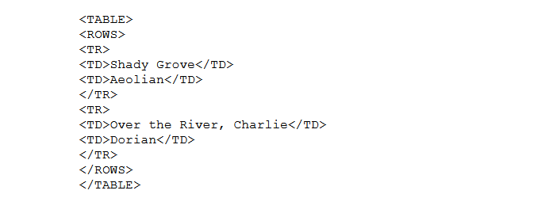

can be represented as a DOM model like this

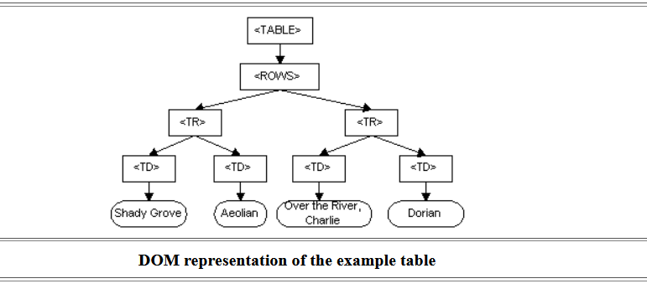

Similarlly when we write HTML code, a tree like DOM of that HTML document is created.

We are given with various **methods and properties** to work with the DOM and add functionalities in the web page

Programming languages like

1. Javascript
2. Java has various built in methods and properties to work with the DOM